**Case Study – Dannys Dinner**

Danny wants to use the data to answer a few simple questions about his customers, especially about their visiting patterns, how much money they’ve spent and also which menu items are their favourite. Having this deeper connection with his customers will help him deliver a better and more personalised experience for his loyal customers. He plans on using these insights to help him decide whether he should expand the existing customer loyalty program.  
  
The sample data is been provided sales table, menu table, members table. There is a set of problem statement which need the insights. Using Sql query fetched the insights

1. What is the total amount each customer spent at the restaurant?  
     
   Select customer_id , sum(price) From menu join sales on menu.product_id = sales.product_id group by sales.customer_id;  
     
   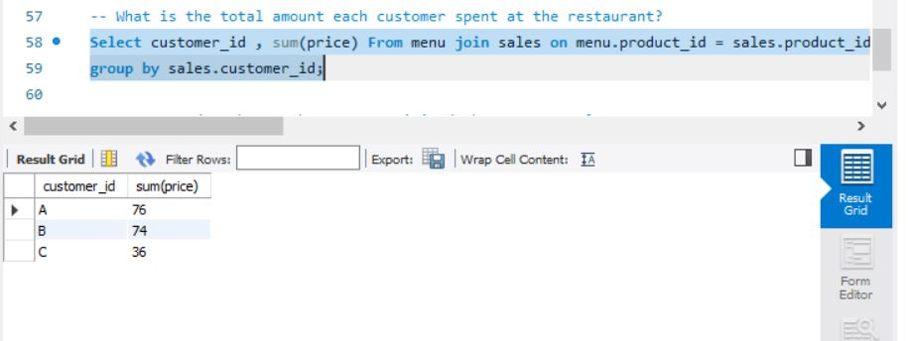
2. How many days has each customer visited the restaurant?  
     
   Select customer_id, count(distinct(order_date)) From Sales Group by customer_id;  
     
   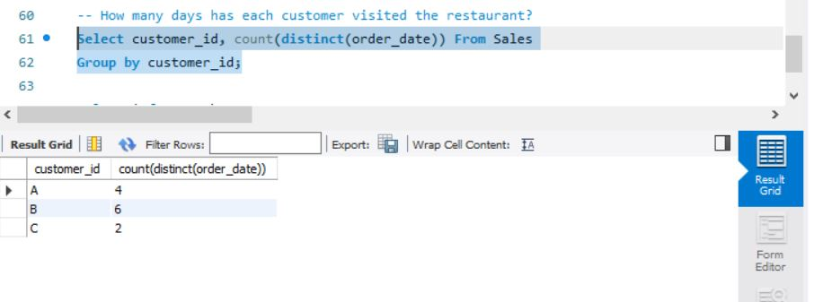
3. What was the first item from the menu purchased by each customer?

With cte As

(

Select sales.customer_id, menu.product_name,

Row_Number() OVER(Partition By sales.customer_id Order By sales.order_date) As rownumber

from sales join menu on sales.product_id = menu.product_id

)

Select customer_id, product_name From cte Where rownumber = 1;  
  
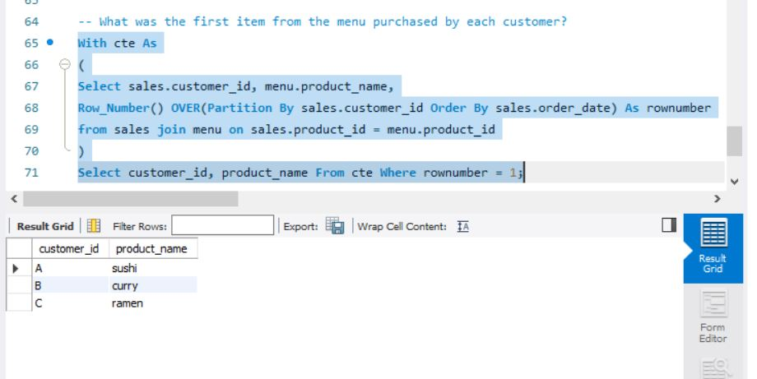

1. What is the most purchased item on the menu and how many times was it purchased by all customers?  
     
   Select menu.product_name, count(menu.product_name) As order_count

from sales join menu on sales.product_id = menu.product_id

Group By menu.product_name

Order By Count(menu.product_name) Desc Limit 1;

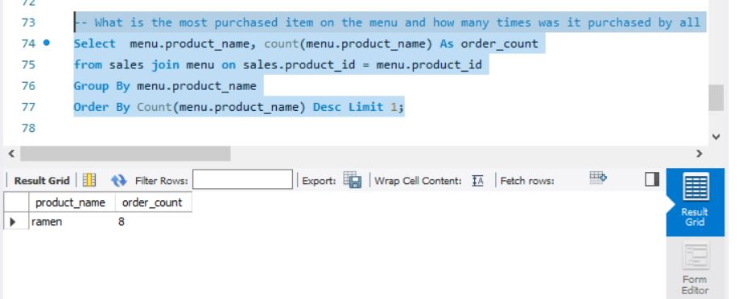

1. Which item was the most popular for each customer?  
     
   With popular_item as (

Select sales.customer_id, menu.product_name,

Count(*) as order_count,

DENSE_RANk() OVER(partition by sales.customer_id Order By Count(*) DESC) as ranks

From sales

join menu on sales.product_id = menu.product_id

group by sales.customer_id, menu.product_name

)

Select customer_id, product_name From popular_item where ranks = 1;  
  
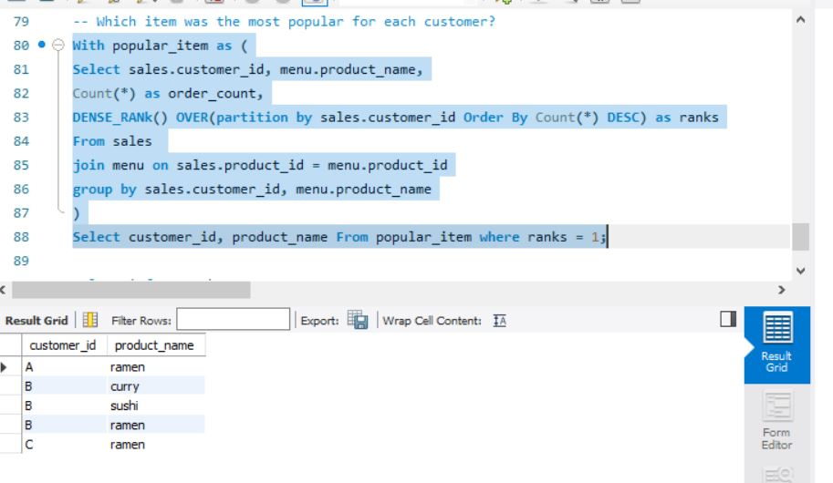

1. Which item was purchased first by the customer after they became a member?  
     
   With orders As (

Select sales.customer_id, menu.product_name, sales.order_date, members.join_date,

DENSE_RANk() OVER(Partition By sales.customer_id Order By order_date) As ranks

From menu join sales On menu.product_id = sales.product_id

join members On sales.customer_id = members.customer_id

Where sales.order_date > members.join_date

)

Select customer_id, product_name From orders Where ranks = 1;

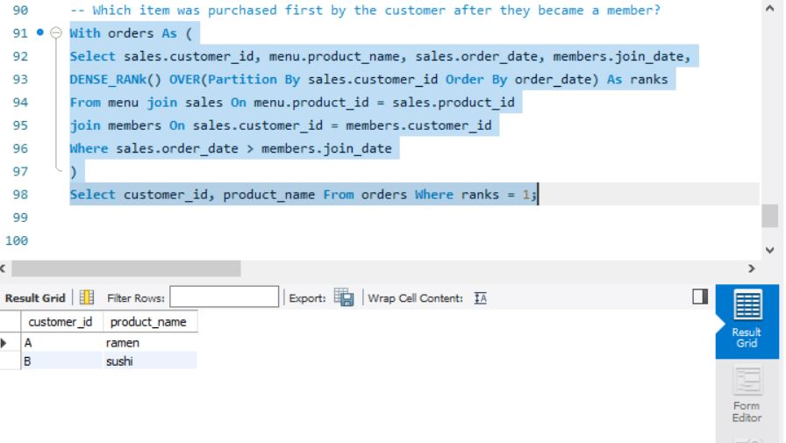

1. Which item was purchased just before the customer became a member?  
     
   With orders As (

Select sales.customer_id, menu.product_name, sales.order_date, members.join_date,

DENSE_RANk() OVER(Partition By sales.customer_id Order By order_date Desc) As ranks

From menu join sales On menu.product_id = sales.product_id

join members On sales.customer_id = members.customer_id

Where sales.order_date < members.join_date

)

Select customer_id, product_name From orders Where ranks = 1;  
  
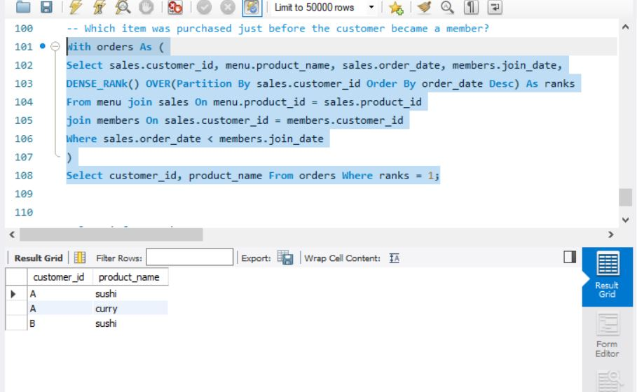

1. What is the total items and amount spent for each member before they became a member?  
     
   Select sales.customer_id, sales.order_date, members.join_date,

COUNT(sales.product_id) as total_items_ordered,

SUM(menu.price) as total_amount_spent

From menu join sales on menu.product_id = sales.product_id

join members on sales.customer_id = members.customer_id

Where sales.order_date < members.join_date

group by sales.customer_id, sales.order_date, members.join_date;  
  
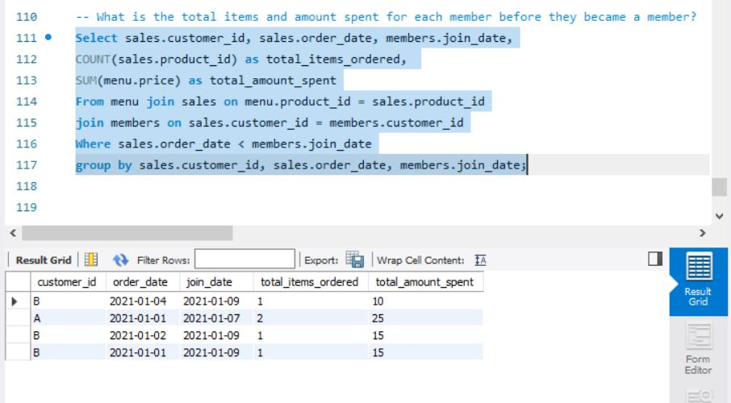

1. If each $1 spent equates to 10 points and sushi has a 2x points multiplier - how many points would each customer have?  
     
   With points as(

Select sales.customer_id, menu.product_name, menu.price,

CASE

WHEN menu.product_name = 'sushi' Then menu.price*10*2

ELSE menu.price*10

END as points

From sales join menu

on sales.product_id = menu.product_id

)

Select customer_id, sum(points) as total_points from points group by customer_id;

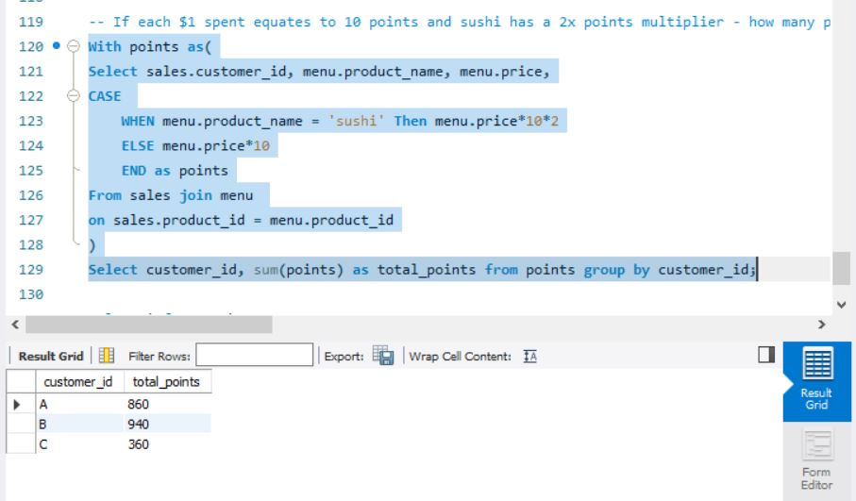

10) In the first week after a customer joins the program (including their join date) they earn 2x points on all items, not just sushi - how many points do customer A and B have at the end of January?  
  
With points as(

Select sales.customer_id, menu.product_name, menu.price, sales.order_date, members.join_date,

CASE

WHEN sales.order_date BETWEEN members.join_date AND DATE_ADD(members.join_date, INTERVAL 7 DAY) THEN menu.price*10*2

WHEN menu.product_name - 'sushi' Then menu.price*10*2

ELSE menu.price*10

END as points

FROM menu

join sales on menu.product_id = sales.product_id

join members on sales.customer_id = members.customer_id

Where order_date < '2021-02-01'

)

Select customer_id, sum(points) as total_points

from points group by customer_id;

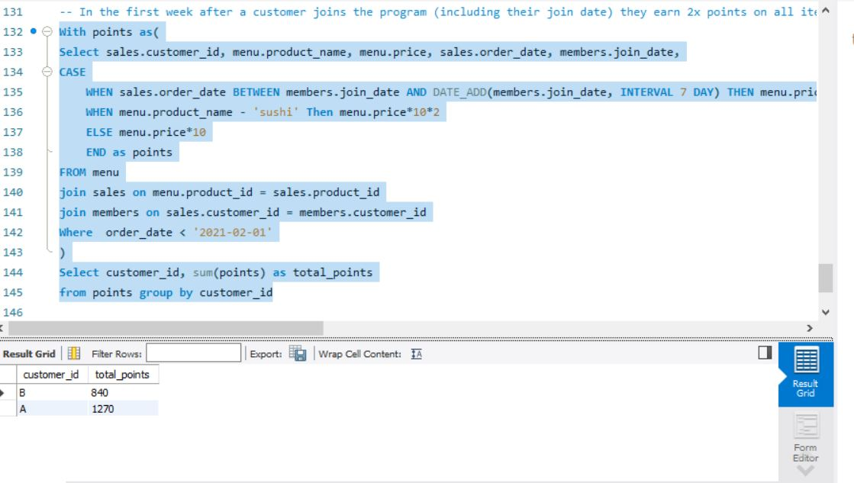

11) Determine the name and price of the product ordered by each customer on all order dates & find out whether the customer was a member on the order date or not  
  
Select sales.customer_id, sales.order_date, menu.product_name, menu.price,

CASE

When members.join_date <= sales.order_date Then 'Y'

else 'N'

END as members

from menu

join sales on menu.product_id = sales.product_id

left join members on sales.customer_id = members.customer_id;

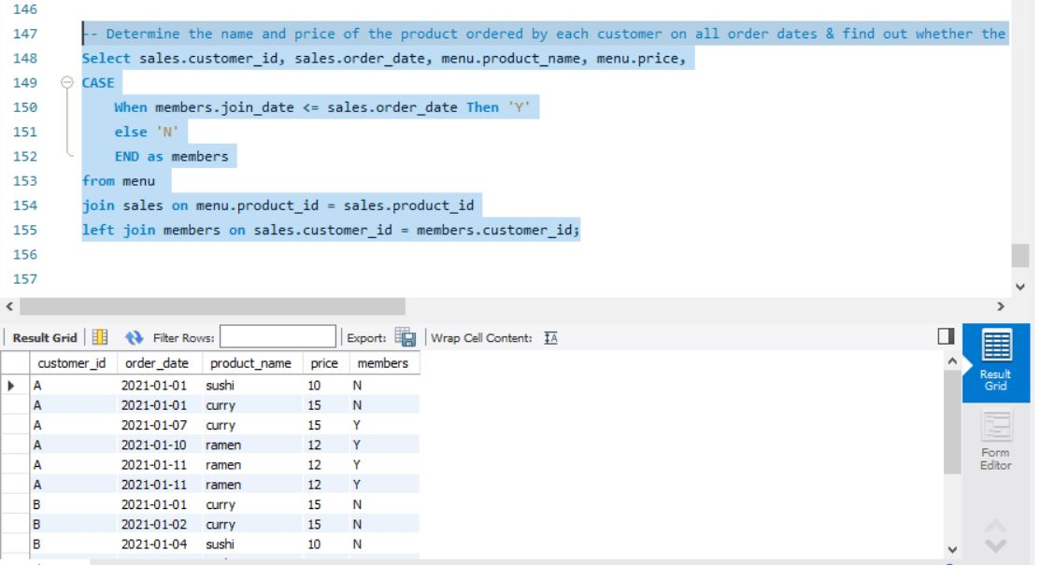

12) Rank the previous output based the order_date for each customer. Display null if customer was not a member when dis was ordered  
  
with ranks as(

Select sales.customer_id, sales.order_date, menu.product_name, menu.price,

CASE

When members.join_date <= sales.order_date Then 'Y'

else 'N'

END as member_status

from menu

join sales on menu.product_id = sales.product_id

left join members on sales.customer_id = members.customer_id

)

Select *,

CASE

WHEN ranks.member_status = 'Y' THEN RANK() OVER(Partition By ranks.customer_id, ranks.member_status Order By order_date)

ELSE NULL

END As ranking

from ranks;  
  
